GIT BASICS

**Install git bash**

* [**https://git-scm.com/download/win**](https://git-scm.com/download/win)

**Create Empty Repository on github.com:**

* Go to github.com. log in
* Click new

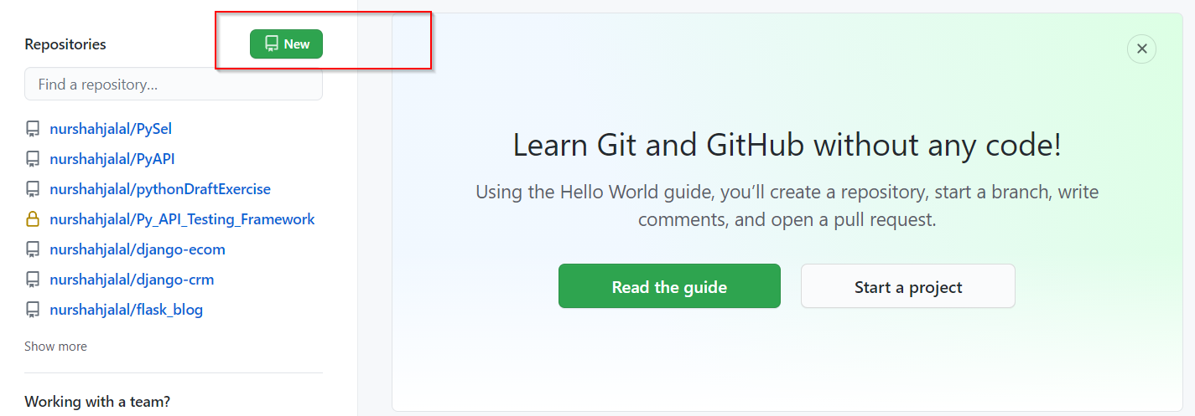

* Enter a meaningful repository name and

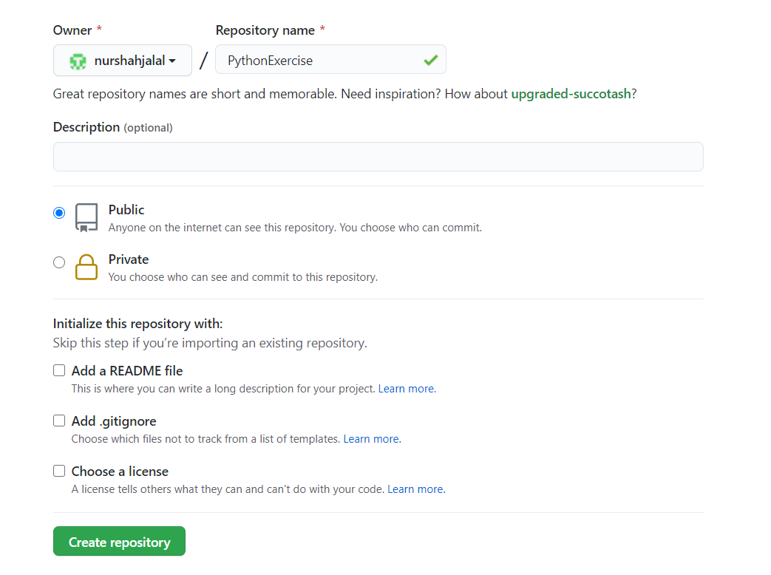

* Hit create repository button
* It will take to next page

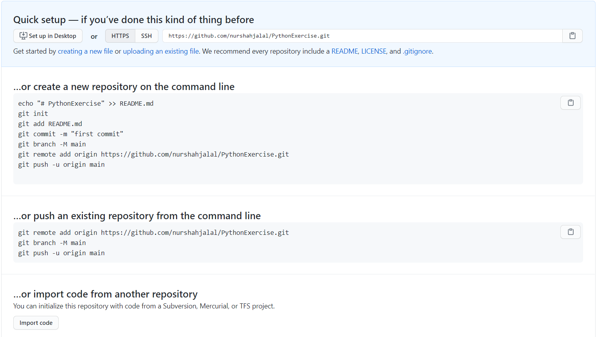

**Associate the empty repository with existing project from your local machine:**

* Once git bash is installed >> open git bash
* Type pwd to see present directory
* Cd to desired folder
* Type the following command :
  + Git init ( a .git folder will be created)
  + Git add . ( all files will be added to git repo)
  + Git add README.md (optional, its standard exercise to add readme file)
  + Git commit -m “Your message” (first commit, ready to push)
  + git remote add origin https://github.com/nurshahjalal/PythonExercise.git

(mention which remote branch you want to use for pushing the code)

* + Git push -u origin master (if you don’t have any other branch, by default it is master)

**Adding files to existing repo and push**

* Once files are added to projects >>
* Type following command to git bash
* Cd to project directory
* Git status ( to see any changes)
* Git add .
* Git commit -m (your message)
* Git push